A set of pixels is just a list of (x,y) coordinates.

Simple operations on a set B:

1. *Translation*:

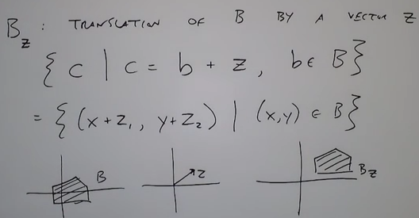

Adding a 2D vector to each point in (x, y) in B

1. *Reflection*:

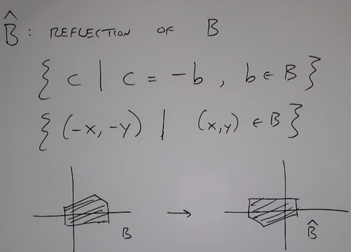

Structuring Element:

* is a small binary array
* helps with filling up or removing pixels in images

1. ***Erosion***:

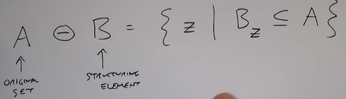

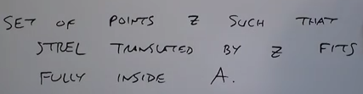

Find all locations where structuring element translated by z will fit inside the original shape

Get rid of extra white pixels that are too small.

Objective:

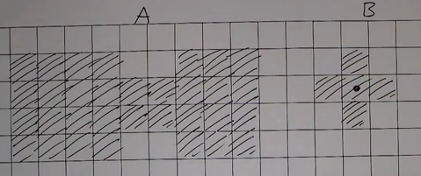

Label all the points in A such that the structuring element B fits entirely within the shape A

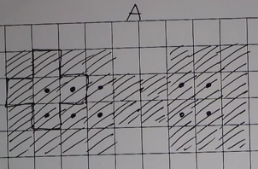

Points where B entirely fits in A (by only considering the center pixel of B NOT all the pixels of B).

Result:

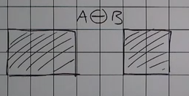

The final outcome however depends on the ***chosen*** structuring element.

So erosion removes: thin lines and isolated dots. But leaves gross detail.

Eroded image is a subset of original image:



1. ***Dilation***:

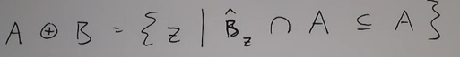

Objective:

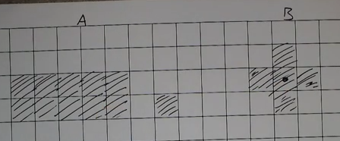

Label points in A and around A such that there is ANY/SOME overlap with B.

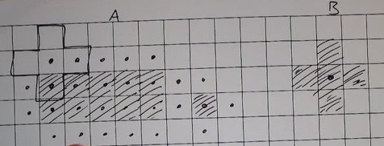

Result:

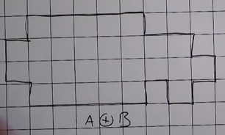

Bridges gaps that are smaller than the structuring element.

1. ***Opening***:



Erode then dilate. Break narrow bridges, eliminate thin structures.

1. ***Closing***:



Dilate then erode. Fuses narrow breaks and eliminates small holes

Now there are many combinations of erosion and dilation like

* Boundary extraction.

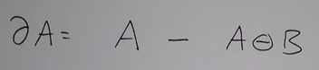

* Flood filling

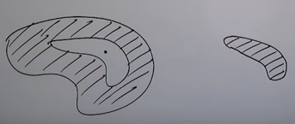

Keep on dilating out from a point in the hole as long as I stay within the hole

***NOTE:*** Morphological operations can also be performed for gray scale images with a gray scale structuring element.

***Watershed Segmentation***

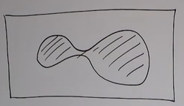

The human eye perceives this as two objects.

The corresponding height map:

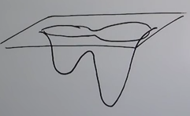

So initially water fills like this:

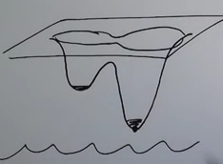 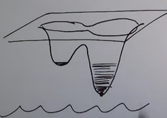 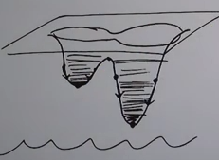

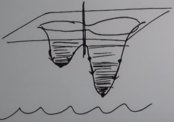

Rules:

* Find the local minima

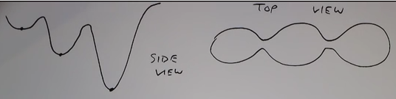

* Punch a hole in each one
* Start rising the water level from the bottom, one unit at a time

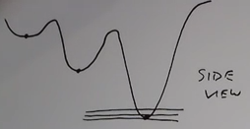

* Keep track of which points are associated with which minima
* At the moment two basins are about to merge, build a single pixel –wide dam to keep them separated.

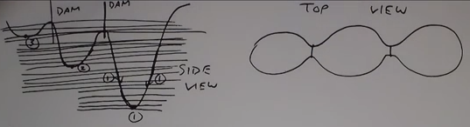

Watershed algorithm is related to morphological operations such that as dilation is performed a barrier is created.

